**Create an Azure function app**

Let’s start by creating an Azure Function app in the portal.

1. Sign into the [Azure portal](https://portal.azure.com/learn.docs.microsoft.com) using the same account you activated the sandbox with.
2. In the left navigation, select **Create a resource**.
3. Select **Compute**.
4. Locate and select **Function App**. You can also optionally use the search bar to locate and create the new resource.

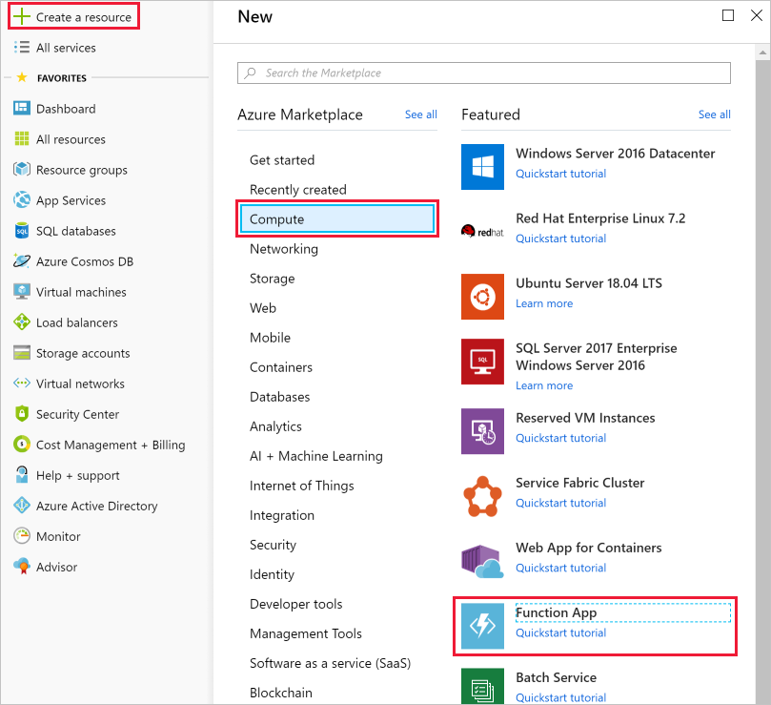

1. Enter a globally unique **App name**.
2. Select a **Subscription**.
3. Select the existing **Resource group** or create a new one.
4. Choose **Windows** as your **OS**.
5. Choose **Consumption Plan** for your **Hosting Plan**. When using the Consumption Plan type you're charged for each execution of your function and resources are automatically allocated based on your application workload.
6. Select a **Location** from the available list below.

The free sandbox allows you to create resources in a subset of Azure's global regions. Select a region from the following list when creating any resources:

* + West US 2
  + South Central US
  + Central US
  + East US
  + West Europe
  + Southeast Asia
  + Japan East
  + Brazil South
  + Australia Southeast
  + Central India

1. For **Runtime Stack**, leave as default *.NET*, which is the language in which we implement the function examples in this exercise.
2. Create a new **Storage** account, you can change the name if you like - it will default to a variation of the App name.
3. Select **Create**. Once the function app is deployed, go to **All resources** in the portal. The function app will be listed with type **App Service** and has the name you gave it.

**Create a timer trigger**

Now we're going to create a timer trigger inside our function.

1. Select the Add (**+**) button next to **Functions**. This action starts the function creation process.
2. On the **Azure Functions for .NET - getting started** page, select **In-portal** and then select **continue**.
3. In the list of quick start templates, select **Timer** and then select **Create** at the bottom of the screen.

**Configure the timer trigger**

We have an Azure function app with logic to print a message to the log window. We're going to set the schedule of the timer to execute every 20 seconds.

1. Select **Integrate**.
2. Enter the following value into the **Schedule** box:

*/20 * * * * *

1. Select **Save**.

**Test the timer**

Now that we've configured the timer, it will invoke the function on the interval we defined.

1. Select **TimerTrigger1**.

**Note**

**TimerTrigger1** is a default name. It's automatically selected when you create the trigger.

1. Open the **Logs** panel at the bottom of the screen.
2. Observe new messages arrive every 20 seconds in the log window.
3. To stop the function from running, select **Manage** and then switch **Function State** to *Disabled*.